**Assignment 5**

**1. Write a C program to simulate Bankers algorithm for the purpose of deadlock avoidance.**

**Resource-Request algorithm:**

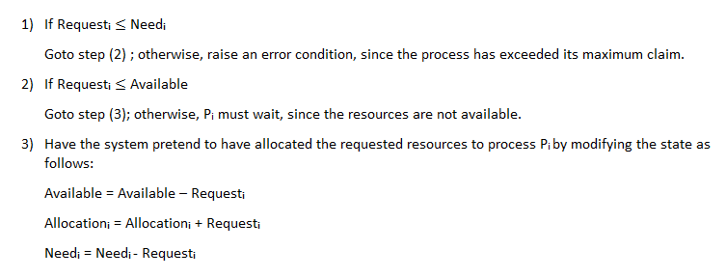

**Safety algorithm:**

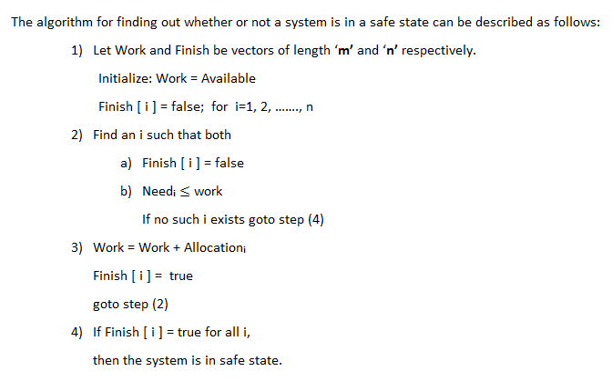

**2. Write a C program to implement deadlock detection technique for the following scenarios?**

**a.Single instance of each resource type b. Multiple instances of each resource type**

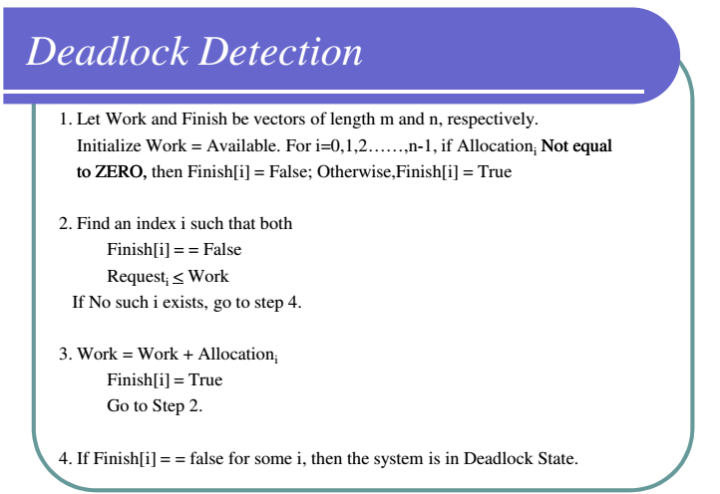

**3. Write a C program to simulate disk scheduling algorithms a) FCFS b) SCAN c) C-SCAN**

a)

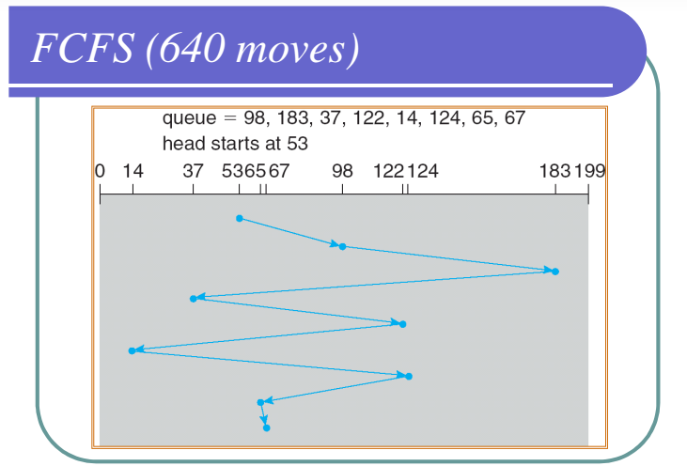

b)

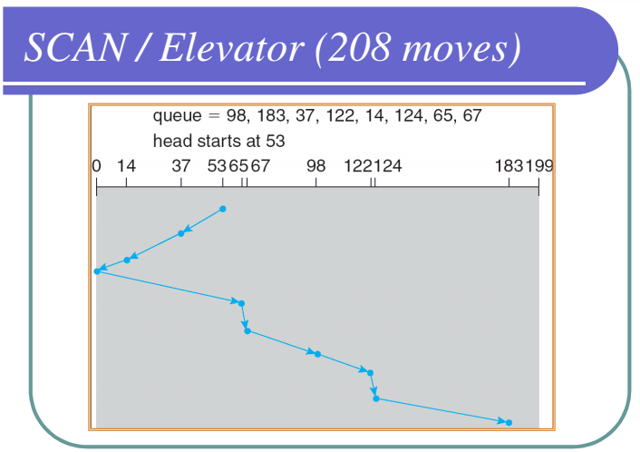

c)

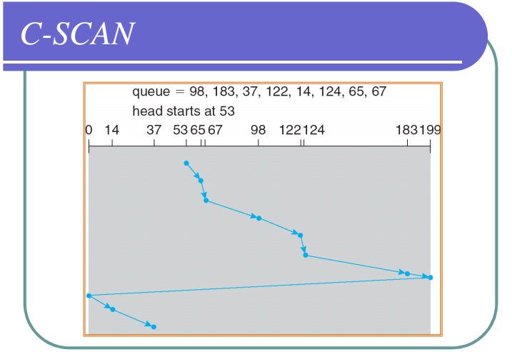

**4. Write a C program to simulate page replacement algorithms**

**a) FIFO b) LRU c) LFU d) Optimal**

Reference String: 1, 2, 3, 4, 1, 2, 5, 1, 2, 3, 4, 5

Check for number of frames, 3 and 4, respectively.

**5. Write a C program to simulate LRU-approximation page replacement algorithm?**

**a. Additional Reference bits algorithm b. Second-chance algorithm**